

RAjshahi University of Engineering & Technology

LAB REPORTRajshahi University of Engineering & Technology

# LAB REPORT

## Topic: Process Creation

## Course No: CSE 3202

Course Name: Sessional Based on Operating Systems RAjshahi University of Engineering & Technology

LAB REPORTRajshahi University of Engineering & Technology

## Department of Computer Science & Engineering

## Department of Computer Science & Engineering

## Department of Computer Science & Engineering

# LAB REPORT

## Topic: Process Creation

## Course No: CSE 3202

## Course Name: Sessional Based on Operating Systems

Submitted By

Submitted By

Submitted By

Submitted By

Saifur Rahman

Roll No: 1703018

Section: A

CSE, RUET

Submitted To

Submitted To

Submitted To

Submitted To

Mohiuddin Ahmed

Lecturer

CSE, RUET

Date of Lab: May 16, 2022

Date of Submission: May 30, 2022

Contents

Program No. 1 1

Program No. 2 2

Process Tree 2

Program No. 3 3

Discussion: 4

### **Program No. 1**

### **Program Topic:** A program that creates a process from another process, takes few integers as input, then sums up all the odd numbers of input if the parent process is running and sums up all the even numbers if child process is running.

#### **CODE**

#include <stdio.h>

#include <sys/types.h>

#include <unistd.h>

int main(){

int n;

printf("Enter the array size: ");

scanf("%d", &n);

int a[n];

printf("Enter array: ");

for(int i = 0; i < n; i++)

scanf("%d", &a[i]);

int sumEven = 0, sumOdd = 0;

for(int i = 0; i < n; i++) {

if(a[i] % 2 == 0)

sumEven += a[i];

else

sumOdd += a[i];

}

int x = fork();

if(x < 0)

printf("Error Occurred**\n**");

if(x > 0)

printf("**\n**This is from parent.. pid = %d.. sum of odd = %d**\n**", getpid(), sumOdd);

if(x == 0)

printf("**\n**This is from child.. pid = %d.. sum of even = %d**\n**", getppid(), sumEven);

return 0;

}

#### **OUTPUT**

#### 

### **Program No. 2**

### **Program Topic:** A program that creates a Process Tree with 3 ‘fork( )’ instructions and determines the condition for accessing each process to do a specific operation.

### **Process Tree**

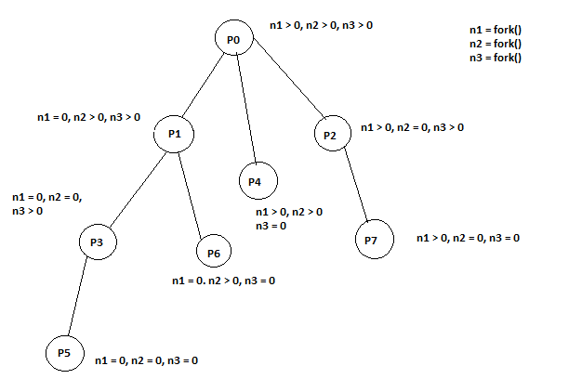

#### **CODE**

#include <stdio.h>

#include <sys/types.h>

#include <unistd.h>

int main() {

double a, b;

printf("Enter two numbers: ");

scanf("%lf %lf", &a, &b);

int n1 = fork();

int n2 = fork();

int n3 = fork();

if(n1 > 0 && n2 > 0 && n3 > 0)

printf("pid = %d, a + b = %.2lf**\n**", getpid(), a+b);

if(n1 == 0 && n2 > 0 && n3 > 0)

printf("pid = %d, a - b = %.2lf**\n**", getpid(), a-b);

if(n1 > 0 && n2 == 0 && n3 > 0)

printf("pid = %d, b - a = %.2lf**\n**", getpid(), b-a);

if(n1 == 0 && n2 == 0 && n3 > 0)

printf("pid = %d, a * b = %.2lf**\n**", getpid(), a*b);

if(n1 > 0 && n2 > 0 && n3 == 0)

printf("pid = %d, a / b = %.2lf**\n**", getpid(), a/b);

if(n1 == 0 && n2 == 0 && n3 == 0)

printf("pid = %d, b / a = %.2lf**\n**", getpid(), b/a);

if(n1 == 0 && n2 > 0 && n3 == 0)

printf("pid = %d, a = %.2lf**\n**", getpid(), a);

if(n1 > 0 && n2 == 0 && n3 == 0)

printf("pid = %d, b = %.2lf**\n**", getpid(), b);

return 0;

}

#### **OUTPUT**

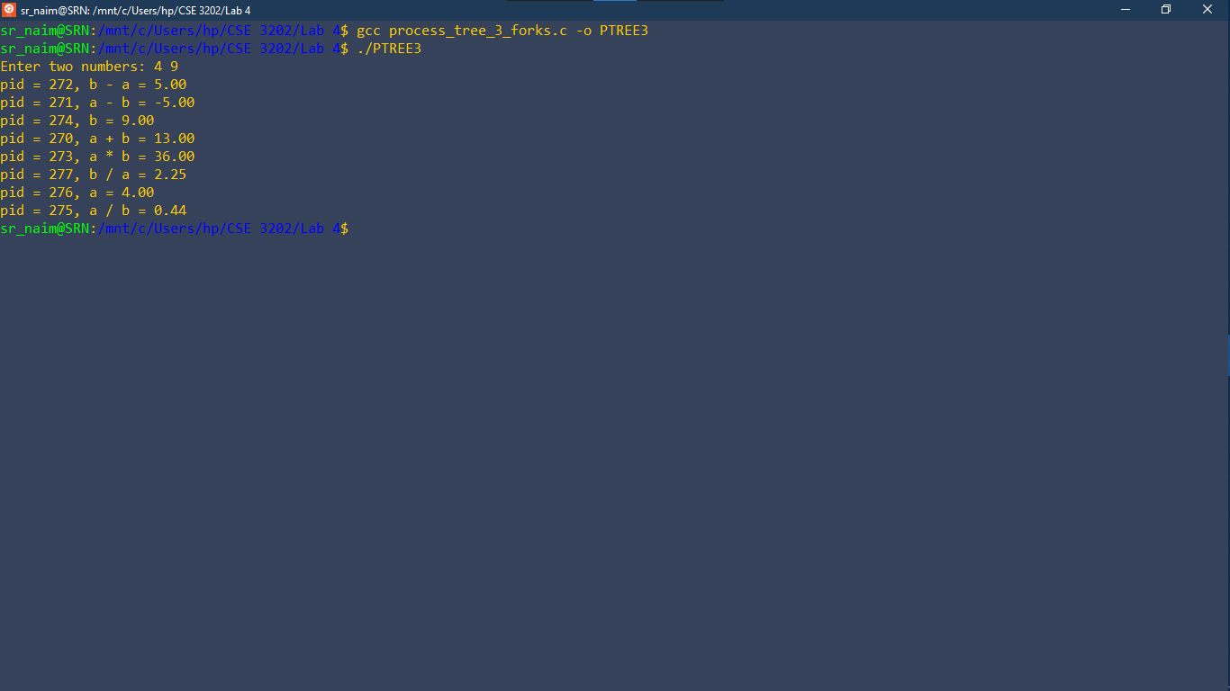

### **Program No. 3**

### **Program Topic:** A program that calls another program via ‘exec( )’ instruction. The called program performs binary search.

#### **CODE (Calling Binary Search.c)**

#include <stdio.h>

#include <sys/types.h>

#include <unistd.h>

int main() {

char *args[]={"./SECOND",NULL};

execv(args[0],args);

}

#### **CODE (Binary Search.c)**

#include <stdio.h>

#include <unistd.h>

int main()

{

int n;

printf("Enter array size: ");

scanf("%d", &n);

int a[n];

for(int i = 0; i < n; i++)

scanf("%d", &a[i]);

printf("Enter search item: ");

int x;

scanf("%d", &x);

int l = 0;

int h = n-1;

while(l <= h) {

int m = (l + h)/2;

if(a[m] == x) {

printf("found at index = %d**\n**", m);

**break**;

}

else if(a[m] < x) {

l = m + 1;

}

else {

h = m - 1;

}

}

}

#### **OUTPUT**

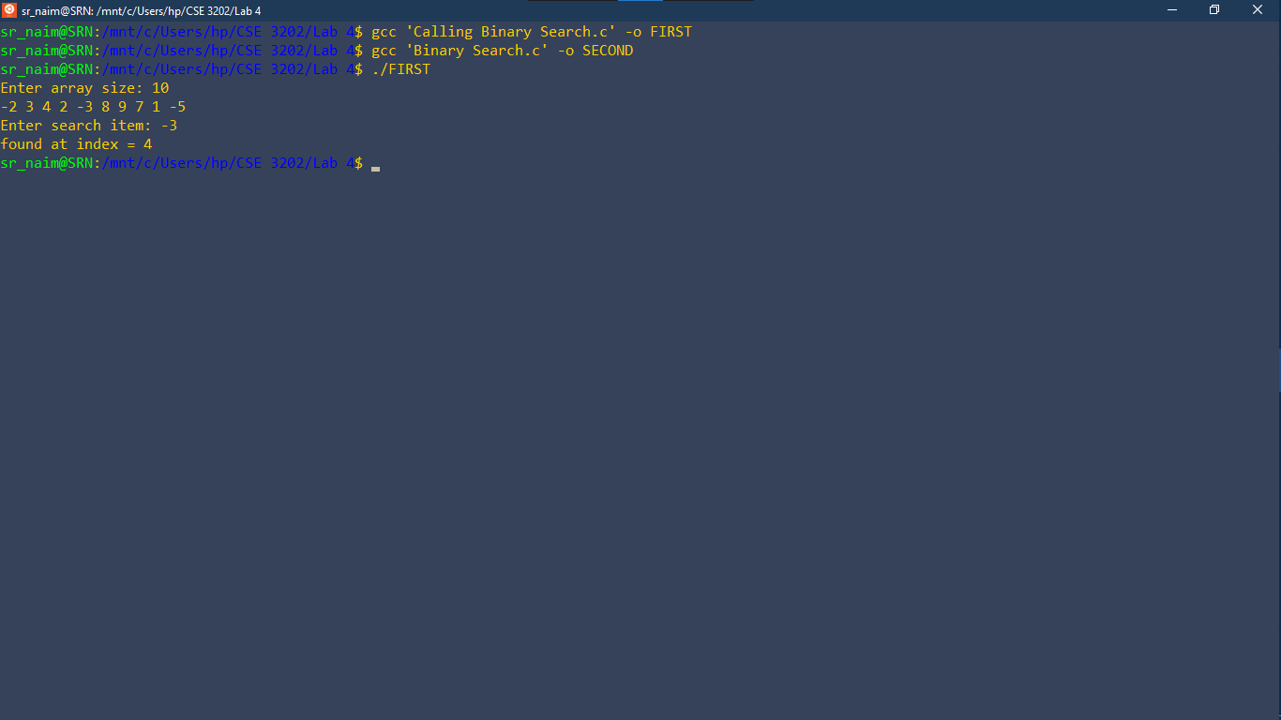

### **Discussion:**

* While creating a process and accessing it. The pid of parent and child processes may differ from one another.

‘getpid()’ gives parent pid

‘getppid()’ gives child pid

* While creating child process using fork(), only one recent fork number will change. Rest of the fork numbers will be inherited from parent process. Child will copy values from parent as ‘fork()’ creates same process.

n = fork(); Here ‘n’ is the fork number

* While accessing another program from a program with exec(), one must be careful about the name given inside *args[]. The given name should be the name of called program’s output file.

In program 3, “SECOND” is the name given in *args[]. And the output file name of ‘binary search.c’ is also ‘SECOND’.